 | International  Virtual  Observatory  Alliance

Domain model for simulations, their results and post-processing

Version 0.1
IVOA Technical Note 2007/03/01

This version:
SimulationDM0.1-20060917
Latest version:

Previous version(s):

Author(s):
Gerard Lemson

Abstract

This specification defines a domain model for the metadata required to be associated with the publication of astrophysical computer simulations in the IVOA. It is the bases for one or more logical data models designed for particular applications concerning such simulations. Its first application is to the Simple Numerical Access Protocol (SNAP).

Status of This Document
This is an IVOA Working Draft for review by IVOA members and other interested parties. It is a draft document and may be updated, replaced, or obsoleted by other documents at any time. It is inappropriate to use IVOA Working Drafts as reference materials or to cite them as other than “work in progress”.
A list of current IVOA Recommendations and other technical documents can be found at http://www.ivoa.net/Documents/.

Contents

1 Introduction 4
1.1 background 4
1.2 scope 4
2 Modelling language and methodology 5
2.1 Reasons for a language neutral, formal data model 5
2.2 The modelling approach 5
3 Scenarios 6
3.1 Running a simulation 7
3.2 Post-processing simulation results 7
3.3 Generalisation (model entities in italics) 8
3.4 Concepts listing 8
4 Analysis model I: packages 10
4.1 Phenomenology, physics and models 11
4.2 Protocol: simulation 11
4.3 Experiment: simulation 11
4.4 Experiment: characterisation 11
4.5 ComputationSoftware 12
4.6 Storage 12
5 Analysis model II: class diagrams 13
5.1 Phenomenology 14
5.1.1 Phenomenon 15
5.1.2 GenericQuantity extends Phenomenon 15
5.1.3 AtomicQuantity extends GenericQuantity 15
5.1.4 BasicQuantity extends AtomicQuantity 15
5.1.5 DerivedQuantity extends AtomicQuantity 15
5.1.6 DerivedQuantityComponent 15
5.1.7 StructuredQuantity extends GenericQuantity 15
5.1.8 Categorisation extends Phenomenon 16
5.1.9 Identification extends Phenomenon 16
5.1.10 Relation extends Phenomenon 16
5.1.11 Decomposition extends Phenomenon 16
5.1.12 Object extends Phenomenon 17
5.1.13 Substance extends Object 17
5.1.14 ScientificArtifact extends Object 17
5.1.15 AstrObject extends ScientificArtifact 17
5.1.16 Region extends Object 17
5.1.17 TangibleObject extends Object 18
5.1.18 Property 18
5.1.19 PhysicalProcess extends Phenomenon 18
5.2 Protocol 19
5.2.1 Protocol 19
5.2.2 Objective 20
5.2.3 Variable 21
5.2.4 InputDataType 21
5.2.5 ConfigurationParameter 22
5.3 protocol::simulation 23
5.3.1 Simulator extends Protocol 23
5.4 Experiment 24
5.4.1 Experiment 25
5.4.2 Result 25
5.4.3 ObjectContainer 25
5.4.4 ResultObject 25
5.4.5 ValueAssignment 25
5.4.6 Characterisation 25
5.5 Experiment::Characterisation 25
5.6 Experiment::Simulation 25
5.6.1 Simulation 26
5.6.2 Snapshot 26
5.7 Storage 26
5.7.1 Storage 26
5.7.2 File 26
5.7.3 DatabaseTable 26
5.8 Software 26
5.8.1 Software 27
5.8.2 CompilationOption 27
5.9 Model 27
5.9.1 ModelEquation 27
5.9.2 ModelEquationParameter 27
5.9.3 ModelEquationVariable 27
5.10 Party 27
5.10.1 Party 27
5.10.2 Individual 27
5.10.3 Organisation 28
Appendix A: UML profile 28
References 31

Introduction
We present a domain model for use in data modelling efforts related to discovery, filtering and retrieval of results of computer simulations of astrophysical systems, objects and processes.

background
During the IVOA interoperability meeting May 2006 in Victoria the theory interest group defined a project to come to a data model for simulations. The first requirement on this model was that it should support the Simple Numerical Access Protocol (SNAP), in a similar way as the SED model supports the SSA protocol and other such combinations are to be made in the future according to the new DAL approach to access protocols. Expected spin-off is support for other efforts within the realm of theory data: publication of non-standard theory resources in a registry, the semantics effort aimed at defining UCDs and keywords for simulation data sets and the registration of simulation code libraries.
We agreed to first create an analysis model [9] of the domain under consideration (also called the universe of discourse). This model will then serve as the basis for further logical models associated to particular applications.

scope
The scope of our modelling effort is ultimately demarcated by the requirements of SNAP. SNAP is required to deal with simulations of objects inhabiting three dimensional, real space, so we are required to model such simulations. Examples are N-body simulations of galaxy mergers, adaptive mesh refinement simulations of galaxy clusters including gas dynamics etc.
No constraints are set on the physics being simulated, or the observables being produced, apart from the requirement that one must be able to retrieve and filter on spatial coordinates and likely time, though static descriptions of spatial structures are included. The motivation for this is that ...[TBD, some reasons in list below, is recurring discussion in SNAP telecons
- Group who proposed this was interested in this kind of simulations and has experience with it
- Results are usually large, requiring sub-setting methods in access protocol. Basic functionality of SNAP.
- Common concept of nearness in space is useful for real space as near-by objects can have influenced each other during evolution.
- Spatial structure functionality (density profiles, clustering etc) well defined for real space.
- Re-simulations of spatial subsets common exercise. Not properly defined for sub-setting on other
- At least one set of observables (space/time) is fixed and does not have to be specified further. Characterisation can concentrate on this.
- Easier connection to spatial observational protocols.
- ...
]

Modelling language and methodology

Reasons for a language neutral, formal data model
Publication of simulations and associated (access, query) services in the IVOA happens by registering them in an IVOA compatible registry. The registry will allow users to query for resources that are of interest to the user. To this end the resources must be described in sufficient detail that the user can make a meaningful sub-selection without requiring him/her to visit the home site of each resource. In our opinion, one of the goals of a data model for a particular class of resources is to define what such a description should contain.
The form this description takes in the registry is initially of less importance. Even if each resource were only described by a block of English text, we would still want to prescribe (or at the minimum, give hints) which aspects of the resource should be included in the description.
A natural language description would suffice for browsing, or (Google-like) text based searches. If we want to allow a more powerful, formal query language, for example SQL, XQuery, or eventually ADQL/VOQL, to be used for querying registries, the description must be formalised accordingly.
At the current state of technology, a more formalised description is required also if we want to have software read and interpret descriptions of resources and base actions on their interpretation. It is one of the stated goals of the IVOA to allow just such functionality. Added to this is the desire that such software can combine the different resources, for which it would be immensely valuable if they were described in the same way.
Finally, more and more datasets are being stored in databases that offer query capabilities that require a formal structure of the data. It will therefore in general not a very big effort for data publishers to describe their data to the IVOA in a similar formal structure, as long as a precisely and formally described model is presented according to which they should perform this task.

With all these points in mind we will phrase our data models in this document in a formal language, in this case UML, to be more precise, as UML Class Diagrams.

The modelling approach
During the interoperability meeting in Victoria we agreed to approach the modelling task via a somewhat formalized methodology. We will start with compiling a list of concepts, terms, words that occur in conversations about the domain. No order is imposed, no structure. We started such a list in the discussions on theory UCDs and semantic vocabulary in Victoria and the further evolution of that effort will be followed. To put the list in a context we write up a simplified story containing the most important concepts and putting them in relation to each other.
The list and story will serve as input to the definition of a so called analysis, or domain model. This is a model describing in an abstract way the universe of discourse for this modelling effort, it describes the part of the world within which the application using the model act. [GL – TBD, find better wording for this in literature]. The goal of this model is to define and structure the concepts that are important for our effort. In a sense it is the translation of the story in terms of the formal modelling language we use (UML).
The domain model is not the model that will be used by the particular applications we are envisioning. That role is taken by the so called logical model for the application domain. The logical model is precise and comprehensive, containing all entities and their attributes and. This is in contrast to the analysis model, which is global, not comprehensive and not structured for any particular application.
Finally we define mappings of the logical data model for the various specific computational environments or contexts within which the applications work. This can mean producing a relational model for storage in a relational database, an XML schema for defining appropriate XML documents, or a Java class library for (re)use by Java applications, for example Java servlets implementing a SNAP service in a tomcat web server.
A special effort is also the definition of reference data. These are predefined objects (i.e. instances of (parts of) the model) that can be used when creating new instances. This is an aspect where we hope to be able to borrow heavily from other efforts such as the ontology of astronomical objects. TBD Expand or scrap

Scenarios
We provide three scenarios that describe aspects of the world we plan to model, our universe of discourse [6]. The first two describe running a simulation and post-processing of the simulation results respectively. These are defined in the SNAP protocol [2] as corresponding to Level 0 and Level 1 data products. As example we use a hydro simulation of a galaxy cluster, but other types of simulation provide similar stories. The example is motivated by X-Ray observations of a galaxy cluster, in which indications for turbulence of the ICM were found (see [13]).
The third scenario generalises the first two, reflecting, in our opinion, the concepts common to both, and, again in our opinion, to most scientific endeavour. These scenarios reflect prior knowledge of the field by the authors, as well as conversations we have had with experts.
The final section contains a simple list of concepts extracted from these scenarios and the conversations, that we feel must end up in the model, or at least must be able to be described by the model.

Running a simulation
An astrophysicist wants to understand a certain observed astronomical phenomenon. This can range over the whole spectrum of astrophysical endeavours, but as mentioned we use as concrete example one from our vicinity stellar spectra, structure and chemistry of interstellar cloud, structure of a galaxy, jet emerging from central black hole, galaxy merger, X-ray properties of a galaxy cluster, large scale organisation of galaxies in the universe, the cosmic micro-wave background. In the case of our example X-Ray observations of a galaxy cluster are to be understood.
First he (for the sake of argument) creates a model for the phenomenon under investigation, in the case of our example turbulence in the Intra Cluster Medium. He wishes to test the model by creating predictions to be compared in detail (i.e. numerically) to the observations.
The model is phrased in mathematical equations and in the underlying case the equations are deemed too complex to solve analytically and the phenomena are too complex to be satisfied by idealised approximations. To come up with predictions from the model he decides to perform a computer simulations.
To this end he may write a computer program that implements numerical approximations to the model equations. In the underlying case similar such codes are known to exist (possibly even registered in the VO!). Here the user decides to use the Gadget SPH code available on from [14].
The code is downloaded and built, realistic initial conditions of the phenomenon are created and configuration files are created containing parameter settings governing the running of the code. Then the code is run and the results of the simulations are stored on a file system for further analysis.

Post-processing simulation results
The Level-0 results of a simulation are further processed to produce (Level-0) data products that are more amenable to analysis for the goal under consideration. Examples of this are cluster finders, density fields, velocity fields, projected maps etc. We make a distinction here between such pure post-processing, and analysis, which in our model produces science ready products. Examples of the latter are correlation functions, luminosity functions etc, products that can be put in a graph and put in a paper. These we do not discuss here.
In the example under consideration the user creates a group catalogue using a friends-of-friends cluster finder. The result of this is stored as a catalogue in a relational database for further analysis. He also creates a spatial density field of the SPH output, by gridding the particle data on a regular mesh. These can be used for visualisation, but also for example for FFTs to determine the power spectrum.
Note that both these results are themselves representations of a spatial system and therefore fall under the domain of the simple numerical access protocol. This makes them Level-1 data products as defined in that protocol [2].

Generalisation (model entities in italics)
By assumption, users of the applications/protocols in this domain are interested in discovering and accessing or retrieving the results of simulations. Actually what they would be accessing/retrieving are the physical artefacts that are produced during the running of the simulation, be they files or database tables, and in which the results are stored.
A simulation is a kind of experiment. Experiments in science must be performed (and described) according to a particular, predefined protocol. Protocols have some general objective which we define as being the determination of properties for particular objects. This determination can be done by observing properties, or as in the current case, by simulating them.
Protocols have parameters that are predefined and that need to be set during the experiment’s initialisation phase.
For simulations the protocol takes the form of a simulator. The simulator is executable code that implements particular numerical algorithms, for approximating models of physical processes.

Experiments produce results. A result is a collection of obijects, where an object is an instance of an objective as defined in the protocol for the experiment. That is, an object contains for an identified entity in the real (well, virtual) world (examples are pixels in an image as objects representing small parts of the sky, sources in a catalogue, photons in an event list, particles in an N-body simulation, or grid cells in a mesh simulation). An object simply assigns values to the various properties that make up an objective. The results finally are stored in (for want of a better name we call) a physical artifact. This may be a file, or a table in a database, or ... . Although we have drawn the objects and their values in the model, in general metadata repositories these will not be represented. However, they do have a definite place in a model of the domain!

The results of the type of simulations we are interested in here are snapshots, representing the state of a part of 3D space at a single point of time. A snapshot contains in general a large number of individual simulated objects (for example particles in an N-Body simulation or mesh cells in a grid based simulation). For each of these simulated objects the result lists the values for all the simulated properties (given by the properties of the objectives in the protocol).

Concepts listing
Here we list concepts that are important for our application domain. No effort is made to impose a particular order or structure. Apart from the stories above (and original conversations), another source for this list could be the result of the theory semantics effort, see the IVOA TWiki page for a current view of that list. That list found its origin in a discussion in Victoria about simulations, where one of us simply wrote down terms used in the discussion.
Some of these words will show up in the model as entities (classes, attributes, relations), others as possible values (enumerations) for attributes, or maybe as officially approved documents containing them as reference data or even simply as things we must be able to say/describe within the confines of our model.

- simulation
- model
- code
- simulator
- algorithm
- object
what are the fundamental objects in the simulation? Example: particle (N-body), grid cell (mesh simulations),
- properties
what are the properties that are calculated for the fundamental objects? Examples: position, velocity, temperature, pressure
- subject
- physics
- (cosmological) parameters
- initial conditions
- box size
- boundary conditions
- hydrodynamics
- gravity
- n-body
- resolution
- post-processing
- cluster finder
- slice
- snapshot
- ...

[TBD – continue this list, incorporating concepts from Semantics list, maybe Object ontology. Also from original domain model document.]

Analysis model I: packages
Here we describe the high level, package/namespace structure of the model. Our proposal represents a slightly modified version of the “Domain model for Astronomy” presented for the first time in [7]. In that document we explain the high level concepts that also appear in the current model, such as experiment, protocol and phenomenon. We repeat here the description of those classes that are of special relevance for the current data model and we describe additions and changes w.r.t. the original model.
The diagram in Figure 1 shows the main components in the model, represented as interdependent packages.

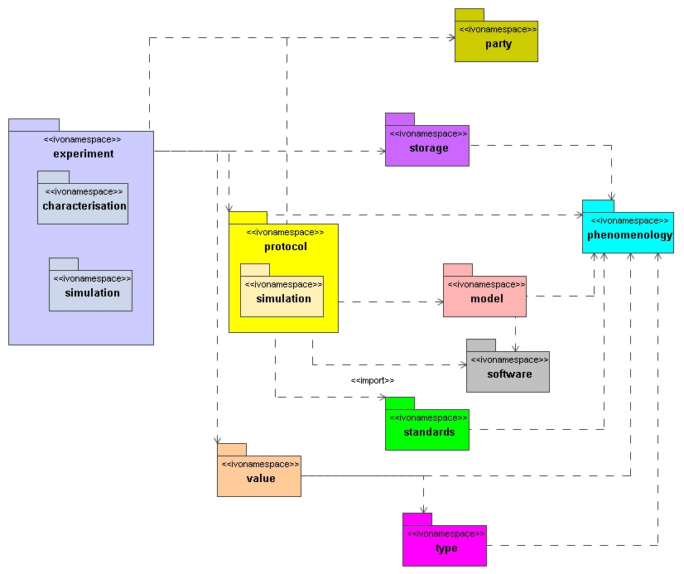
Figure 1 Package/namespace structure of the domain model proposed in this document

Phenomenology, physics and models
The concepts in the phenomenology namespace represent real world phenomena that can be measured, calculated, simulated etc in the scientific process. We have used the SI model [8] for inspiration in defining the contents of this package.
Physical processes were not yet explicitly captured in [7], but are necessary for describing what simulations intend to mimic.

Protocol: simulation
We introduce the concept of a simulator in the model to correspond to a protocol (see [7]) for running simulations. The simulator itself is built from software components that implement numerical algorithms that approximate physical processes. These

Experiment: simulation
A simulation is a computer experiment in which a simulator is used as the protocol. In general one needs to build the source code and create an input file with parameters, sometimes produce an initial conditions file. The results in general come as files written to a file system.

Experiment: characterisation
The model presented here is mainly a model for metadata describing simulations and their results with the purpose of supporting discovery of those simulation results one is interested in. The actual data are not supposed to be contained in instances of this model, and this implies that queries based on the actual data can not be phrased in terms of the model. The main reason is that in general the data themselves are very large, are not co-located and not stored in forms that allow easy implementation of a query language of the complexity required for the domain model itself. For example, we do not assume as our requirements on the model that it should allow detailed queries like “find all images in the VO that have at least 15 pixels with their flux in the range 10-11 ... [TBD – add a proper unit here]. For a system to be able to answer this kind of question implies that it must have access to the actual data. This we expect not to be in existence within the near future.

Nevertheless it is useful to have some way of querying after the real content of the data, but in a way that allows such information to be stored alongside the metadata. This in a sense is what the characterisation [3] effort aims at, to find ways in which this can be done. The approach taken in that effort is to characterise the various axes that define the multi-dimensional configuration space of a given observation (for example). This goes in several levels of refinement, which in [3] are named location, bounds, support, sensitivity etc.

The model in [3] is meant to be implemented [GL – Is this right ?] and is mainly influenced by observational datasets. In the simulation analysis model here we will take a step back and see where in the model there is a place for characterisation like concepts.

In the model we want to be able to characterise the results of simulations, in such a way that supports discovery. As described above, a result is a collection of one or more objects, all of which are identical in their structure (in OO terms, have the same type). If there were only one object in a result, it could be stored easily with the metadata. The problem is that there are in general a very large number of objects: millions of pixels, hundreds of millions of galaxies in a catalogue, billions of particles in a large cosmological simulation.
The way one usually deals with characterising large collections of similar values is to use statistical techniques. This is the language used in the current model and it will show that there are relatively straightforward mappings to the terminology of the Characterisation model [3].

ComputationSoftware
Simulators are implemented in source code, similar for code used in post-processing the results. Nevertheless we feel [TBD correct?] that the detailed description of software is beyond the scope of the current first draft of the model. We feel this is not unique to simulation codes and simulation post-processing codes, but generic to all data models requiring the description of software products. We therefore give only a very schematic model for this part, merely containing some place holders to be used by other aspects, but not yet completely described.
[TBD Someone willing to take responsibility?]

Storage
This package deals with how results of experiments are stored. It is intended to provide a model for describing data formats, whether a file system is used, or a relational or XML database, possibly standardised access protocols etc.
Similarly to the previous subject, we feel it is not the place of the current modelling effort to describe this package in detail as it is common to many domains. There might be a place for some detailed work if there were standard data formats for simulations similar to FITS. Most codes however create their own storage formats, and while some may use the HDF5 standard, the use of that standard is not at all prescribed, no astronomy standard keywords exist.
Instead we feel that is the task of the specific data access protocol to prescribe the valid format(s) for that protocol. Here guidance may come from the results of the Quantity data model [TBD ref].

Analysis model II: class diagrams
Here we describe the contents of the packages introduced in the previous section. The description is, similar to that in [7], organised along class diagrams of the individual packages, the model as a whole is too large for its diagram to fit nicely in this document. Each section contains the UML diagram and a description of each illustrated class and relation. The UML syntax we used is described in Appendix A. Abstract classes are italicised and inheritance relations are indicated with the “extends” keyword.
In our description of the classes and their interrelations we will try as much as possible to provide concrete examples. These are derived from the concrete data models presented in the companion document “Concrete examples of simulation data models” [15].

Phenomenology
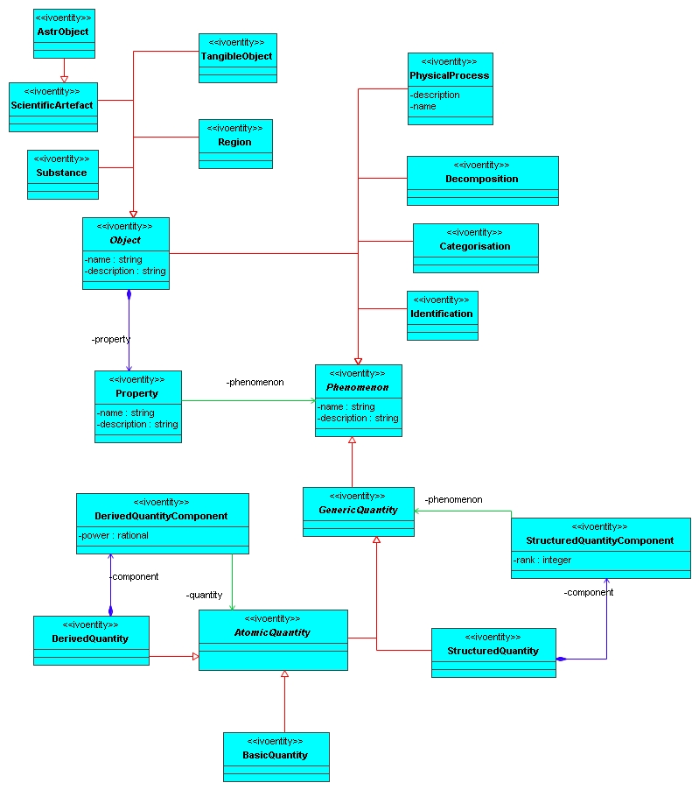
Figure 2 The classes of the phenomenology namespace

This package describes the phenomena that can be measured, calculated, simulated etc in the scientific process. In the design of this package we have used the SI model as explained in [8]. In particular its hierarchy of “quantity in the general sense” to “physical quantity”. There is quite some overlap (we hope) between the concepts in this package and those represented in the Ontology of Astronomical Object Types under development in the IVOA Semantics working group. All references into this namespace can hopefully be implemented by using some referencing scheme for that ontology.

Phenomenon
This class models the generalized concept of a property that some subject may have. Examples are length, mass, shape, galaxy type. Implements Fowler’s [9] PhenomenonType and generalizes SI’s “quantity in the general sense” (see [8]).

GenericQuantity extends Phenomenon
Those phenomena that correspond to numerical quantities (in the general sense, as defined in [8]), possibly structured. Examples are length, mass, area, shape.

AtomicQuantity extends GenericQuantity
Models a generic quantity that can be expressed using a single value. These include basic quantities such as length, mass, temperature, but also derived quantities such as area(=length²) and velocity(=length/time).

BasicQuantity extends AtomicQuantity
Models a basic numeric quantity, including but not restricted to SI’s 7 base quantities, length, mass, time, electric current, thermodynamic temperature, luminous intensity and quantity of matter. To these SI associates Units.

DerivedQuantity extends AtomicQuantity
A phenomenon that can be expressed in terms of other quantities, in particular base phenomena. Includes, but is not restricted to, SI’s derived quantities [2].

DerivedQuantityComponent
Contained in DerivedQuantity. Implements the aggregation of its container class in more basic numeric phenomena. Adds the power with which component quantities apear.
Examples: area = length*length = length²; velocity = length*time⁻¹.

StructuredQuantity extends GenericQuantity
Models structured phenomena, which for now we assume will always be numeric (as we have not yet seen any other examples). Examples of this are position, shape. These can be expressed in terms of more fundamental phenomena in some hierarchy.

Categorisation extends Phenomenon
description
Implements the phenomenon that models classification properties of subjects. That is, we can discuss, for certain subjects, that they belong to a certain class.
Examples: galaxy type, stellar type.
attributes
- name: string
- description: string
references

note
It may be that someday this will be expressed as another special subtype of numeric phenomenon, for example when we can give a quantitative description of what it means to belong to a certain class. However, the act of classification sofar is different from the act of measuring more standard numeric properties. For this reason, and following our methodology stated in Error: Reference source not found, we create a separate phenomenon for this.

Identification extends Phenomenon
Description
Represents the phenomenon where objects are identified as being the same as another object. This can be performed by naming them or by creating an explicit identity relation between the objects. This phenomenon is important in describing the result of a cross-match of catalogues for example, or indeed of what is usually meant by the scientific action of identifying an unknown source

Relation extends Phenomenon
description
Represents the phenomenon that objects can be related to other objects in some form.

Decomposition extends Phenomenon
description
This phenomenon describes how a subject can be described as being built from other subjects.

Object extends Phenomenon
description
The “thing” that is being examined, of which properties are evaluated, measured.
Examples are astronomical objects, regions (including points) of space, also scientific artefacts such as source, image, which are the subject of analysis experiments.
attributes
contains
- Property
A subject is really defined completely by the set of its properties. These are by definition the only observable properties of the subject, i.e. thos aspects by which the subject can be known, identified.
references

Substance extends Object
Description
Represents substances such as water, gold, wood.

ScientificArtifact extends Object
Description
Represents objects defined in the scientific process. In particular objects defined as categorisation of observed events such as neutrino, proton, but also abstract objects such as the group SU(3).
TBD why different from TangibleObject ?

AstrObject extends ScientificArtifact
Description
This class corresponds to the AstrObject defined in the Semantic working group’s ontology (see [10]). It represents concepts such as star, galaxy etc. These are scientific artefacts in the sense that they represent categories astronomers have defined to categorise classes of observed sources.

Region extends Object
Description
This class is intended to represent regions of space as an astronomical subject of investigation. This type of Object is important especially for astronomical observations.

TangibleObject extends Object
description

Property
description
Objects are known/observed through their observable, measurable properties. We define Property as the assignment of a Phenomenon to the parent Object. The object is described fully by its complete set of properties. One may say that the object is defined by its properties. Through its composition relation with Object it corresponds to the quantity in the particular sense as defined in [8].
attributes
- name: string
references
- phenomenon: Phenomenon

PhysicalProcess extends Phenomenon
description
Apart from static observable phenomena, there are also phenomena that deal with evolution, motion, change, interaction. These we classify under the PhysicalProcess class. This class is important for a simulation data model as we need ways to specify which physical processes are modelled by a particular simulation code.

Protocol
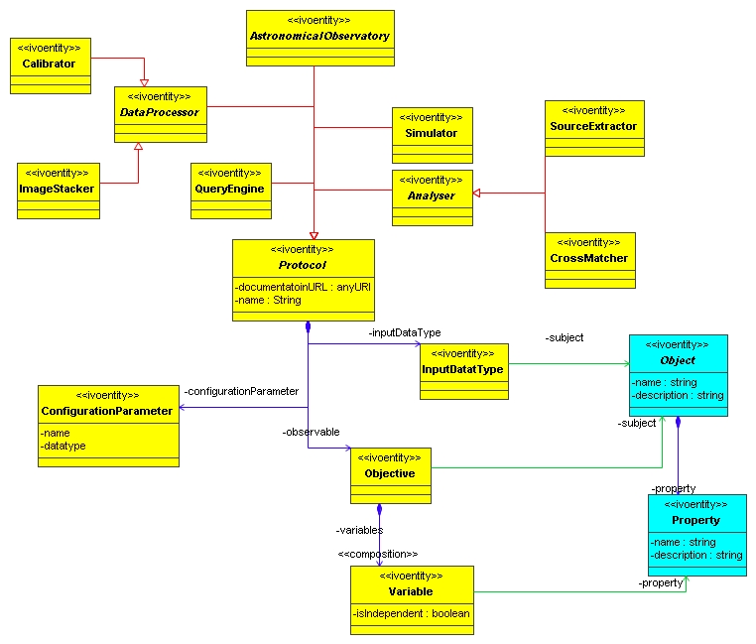
Figure 3 Diagram of the protocol package in the domain model. Abbreviated and adapted version of the corresponding package in [7].

This package contains classes representing the “way in which scientific experiments are performed”, not the actual experiments themselves. …

Protocol
description
Protocol encapsulates a description of how a certain experiment can be performed. It can be seen as a blueprint that can be followed to execute a given experiment. It is separate from the experiment execution, which we capture in Experiment, as a given protocol can be used to describe the workflow of many different actual experiments.
The protocol describes the goals of the experiment, the parameters that are available to change the setup of different experiments performed according to the same protocol, which includes the input data that are required.
There are various examples that can illustrate this concept more clearly by comparing the protocol to its execution:
- A configurable application ala SExtractor which takes an image and extracts a source catalogue from it according to a configuration defined by a set of parameters
vs
executing the SExtractor executable on a given image using a particular parameter file providing a source catalogue.
- simulator : code with standard configuration files required to execute it
vs
simulation: particular initial conditions and parameter settings for a given simulator.
- “observatory” in the sense of a given possible telescope configuration, with a standardised observation proposal form [TBD to be expanded/corrected by an expert on observations]
vs
an actual observation with a particular pointing of the telwscope and exposure time

Attributes
- documentationURL: anyURI
- name: string

Collections
- observable: Objective
- inputParameter: ConfigurationParameter

Objective
description
As the name implies, this class encapsulates the ultimate goal that can be obtained by experiments according to this protocol. However, we do give this an interpretation that possibly differs somewhat from the usual interpretation, which we think is in the eyes of the beholder. We try to model objective in such a way that it might attract the interest of people who do not necessarily have the same scientific goal as the producers of the data.
In this model it is assumed that the objective of an experiment is to assign values to one or more properties of an object that is being investigated, or simulated, or ... . An objective is the set of information about a given subject and if multiple different subject types are investigated a corresponding collection of different objectives may be defined. An actual experiment may achieve a given objective more than once when different subjects of the same subject type are being determined (i.e. observed or simulated or ...).
An example of the latter is that in this model the objective of an experiment that produces an image is the data corresponding to a single pixel, not the complete image. That is, the subject is a direction in the sky from which photons may have hit the given pixel, not the whole region covered by the complete image.
The pixel represents the smallest connected combination of data units (position+flux+time of observation) that can be described and that someone may be interested in. The image is obviously a collection of pixels, corresponding to a collection of subjects, and we do not imply to say that it is not ultimately the whole collection of pixels that was the goal of the experimenter.
We model the objective in terms of the smallest meaningful components. This component is uniquely defined by the subject and kinds of properties, that is the phenomena that are being measured. This ultimately determines whether another user may be interested in the results of this particular experiment.
Notice for example that to obtain information about some contguous region in the image, a partcular source for example, the experimenter wil perform another experiment, according to an analysis protocol, to extract that information. This will be described as a new objective, the type of which will be source for example. Or they can analyse the image as a whole and calculate statistics for certain regions. It is only in this phase that objectives are defined that go away from the single pixel.

Variable
description
An objective is defined formally as the collection of properties of a given subject type it determines. These properties are connected to the objective using this associative Variable class.
This class may contain an indication of whether the variable is dependent or independent. This is still being debated. An alternative is that independent variabeles should really be part of the configuration parameters. [GL – Needs further discussion.]

InputDataType
description
Many types of experiments (protocols that is) use existing data products to create new ones. This is particularly true for analysis and data processing. This class encapsulates the kind of imput data that is being analyzed or processed. An example is a source extractor that requires an image.
references
- type : Object
The kind of data that is being analysed or processed.

ConfigurationParameter
description
Compared to the domain model in [7] we simplify the configuration description simply as a list of parameters.
attributes
- name: string
- datatype: string

protocol::simulation
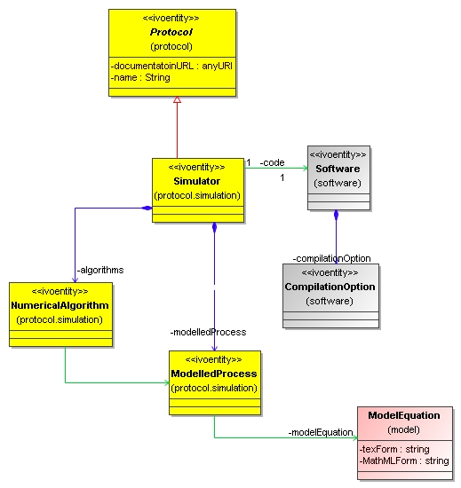
Figure 4 The simulation sub-package of protocol.

Simulator extends Protocol
description
A simulator is a special kind of protocol in which using approximations of physical processes are expressed in software allowing approximations of physical systems to be evolved in time.

Experiment
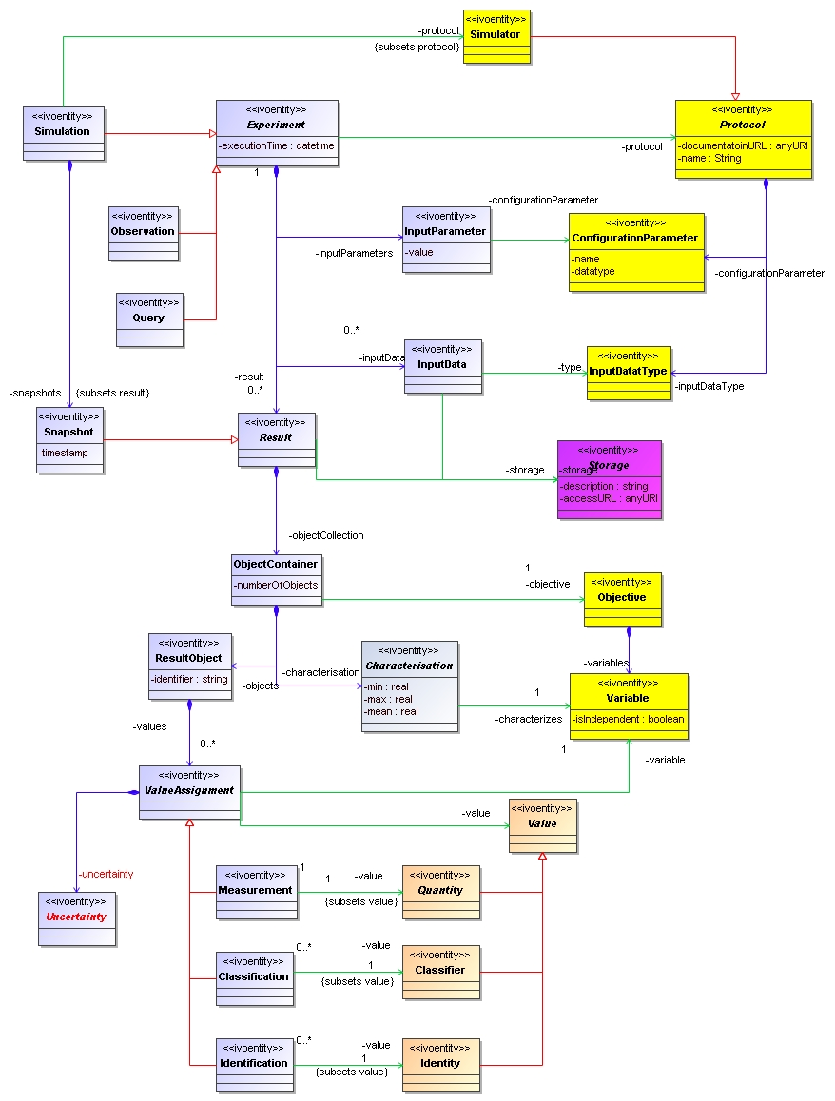
Figure 5 The experiment package (in grey)

Experiment
For the present model we are particularly interested in the Simulation subclass of Experiment and its structure. This sector of the model is described in 5.6.

Result
A result gathers various collections of result objects together. Each of these collections is defined by a common object type. We have

ObjectContainer
In [7], a Result was itself seen as the container of its objects, with different results corresponding to the different Objective of the Protocol. We realise that the semantics of Result require it to hold on to different types of ResultObjects (i.e. with different Objective references) at the same time. This could still be managed, by giving each ResultObject its own Objective reference, but we think it is useful to define a new type that is meant to store objects of a single type only. So compared to the original model in [7], we have added a class between the ObjectContainer. This class references the Objective and all ResultObjects contained by it must be of the same type. An important reason to introduce this class is that it serve as anchor for a ResultCharacterisation. The container can be asked for the number of objects it contains and for statistical information about their properties.

ResultObject

ValueAssignment

Characterisation
This class represents a characterisation of a collection of objects using a small number of quantities. We identify two different characterisations, one we label APrioriCharacterisation and one we label APosterioriCharacterisation. The former characterises the possible values that variables can take, their domain. The latter characterises the actual result, using statistical quantities that describe the distribution of the actually measured (or calculated) variables.
It is the APrioriCharacterisation that is intended to be characterisation data model [12]. The characterisation part of this model is worked out in slightly more detail in the next section.

Experiment::Characterisation
The results of a simulation or post-processing routine are in general large.
For many purposes it is useful to have summarising information about the results, for example for discovery and querying.

Experiment::Simulation
The diagram in

Simulation
This class represents a simulation run as an experiment that is performed with a simulator, which is represented by the reference to the Simulator protocol.
[TBD In the proposal a simulation produces snapshots as its result. This must be discussed.]

Snapshot
For most simulations that model evolution of systems, one can identify discrete points of time at which results are stored. We will define a Snapshot as a special type of result representing the complete state of the system at an identified time.

Storage
This package contains classes describing how data is stored in persistence storage media. This can be in simple (flat) files, but also in a database.

Storage
This class represents how a Result is stored on physical storage media. It should represent more than a simple statement that a result is stored in a file, there must be a description of the way in which the result objects and their values are stored and how they can be obtained. There may be a relation to the Quantity data model here.
[TBD We need to allow a result to be stored in multiple files. ]

File
This represents storage in a simple file, possibly with extra structure defined elsewhere. For example VOTable, FITS, CSV. But also binary files for which structure and/or access methods have been explicitly defined.

DatabaseTable
A table in a relational database. Described in accordance with the

Software
[TBD This package is at the moment very much under-designed, though imho it is pretty obvious what is intended and has been discussed especially by Frank Le Petit and collaborators if I remember correctly. ]

Software

CompilationOption

Model
Model presents an indirection between the physical process, and the modelling of the process. There is not necessarily a 1-1 relation between a process and models for the process. This observation comes from a number of examples of processes captured during interviews about the model with scientists. An example is “star formation” as a process. For this there is clearly not a single accepted model, as there is for “Newtonian gravity”.

ModelEquation
A mathematical expression representing a (part of a) model for a physical process. One needs such a mathematical expression to be able to implement the process in a simulator for example.

ModelEquationParameter
This represents a parameter in a model. It corresponds in general to a phenomenon that is given a certain value. Some of these may be free parameter of the model, others may be fixed. For examples of the latter consider the speed of light, Planck’s constant, G etc.

ModelEquationVariable
This object refers to a property of an object that can evolve or otherwise be determined, change by physical processes.

Party
Represents the world of people, organisations etc that can show up in different places in the model. They will do so in particular roles, for example that of data producer, data curator etc. Some of these roles may be represented as classes in their own right (ala Curation in the Registry Resource model [1]), others simply as references to Party or one of its subclasses.

Party
Abstract base class representing an individual or organisation one can have a relation with, that can be responsible, that can do things.

Individual
Represents a person. Will have a name, and in general attributes allowing the person to be contacted/located such as email, telephone. May have one or more affiliations to an organisation.

Organisation
An organisation when it can play a role in the model, for example ownership of data. May have attributes indicating the type of organisation: university, research, commercial.

Appendix A: UML profile
Our analysis model is defined as a UML class diagram. In defining the model we use a subset of the available syntactic elements, plus particular specialisations defined as “stereotypes”, shown as words within «…». We list and describe these elements here.
UML2 [TBD reference] allows one to formalise such a subset plus specialisations into a UML profile. Profiles are for example useful for code generators. We have defined such a profile for our domain, and implemented this in MagicDraw [8]. That tool is also used in creating the diagrams in this document:

The following elements are used. The first name refers to the official UML name, the italicised word to the way we refer to them in the text.
- Package: package, (ivo)namespace
Container of subpackages, classes and datatypes. As all our binary assoaications are navigable and unidirectional, we do not view assoaications as being directly contained by the package, but by the class that can navigate the association. All UML packages we use get the stereotype ivonamespace. Some packages are sub-packages of others, this is indicated by drawing the child package inside of the parent. See the packages diagram in Figure 1 for examples of this.
Symbol :
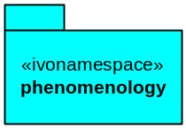
- Dependency: dependson
Uniderectional relation only used between packages. Indicates that the contents of one package (may) depend on (that is, can navigate to by means of a reference) the contents of another package. This relation is transitive. The graph created by the dependency relation is a directed, acyclic graph (DAG).
Symbol:
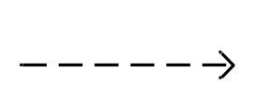
- Class: class, type
A class encapsulates a concept with class properties (in contrast to DataType), which means that ... [TBD complete this description.]
A class can be abstract or not. In the latter case we say it is concrete. This is indicated in the symbol by the name being slanted (abstract) or not. Only concrete classes can have instances. In the methodology we use we will identify concrete with final in the sense of Java. That is, concrete classes can not have subclasses.
Symbol:
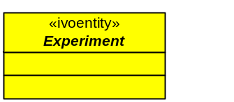
NB
As we are discussing a conceptual model here, it might be better to talk about type iso class. It can be argued that a class is an implementation of an (abstract) type. According to Fowler [9], types correspond more to interfaces, not to implementations. Here and elsewhere in the text we mix the concepts, the more so as we do not use the UML interface concept here anyway, so the danger of confusion is minimal.

- DataType: data type
A data type represents a simple concept that does not have its own, in contrast to object types. They are used to indicate the data types of attributes.
Symbol:
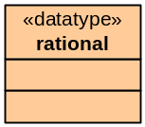

- Generalization: specializes, extends
This relation indicates an “is-a” relation. It is unidirectional and transitive and points from the “subclass” to the “base class”. The subclass inherits all properties (attributes, collections, references, operations) from the base class. We use single inheritance only.
Symbol:
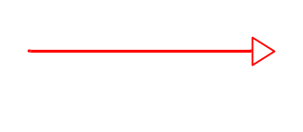
- Composition: contains/containedin
The way we use composition is as a unidirectional binary association from parent (container) to child (containee) that is not shared (i.e. has aggregation value “composite”). The association end at the child’s end is named. Sometimes the composition stereotype is shown explicitly.
Symbol:
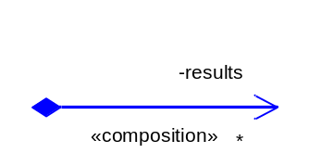
- BinaryAssociation : reference
A reference is a unidriectional binary association directed from referrer to reference. The association end at the reference side is named and has cardinality 0..1 or 1. The association end at the referrer’s side is unnamed and has cardinality * for shared references, or 0..1 for “owned references”. Sometimes the reference stereotype is shown explicitly.
Symbol:
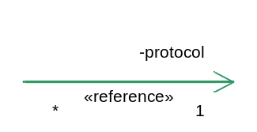
- attributes: attributes
Attributes are fields on classes whose type is a “simple value type” or a custom DataType. Attributes are always of cardinality 0..1 or 1.
Symbol (as the middle cell in a Class symbol):
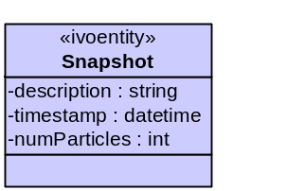
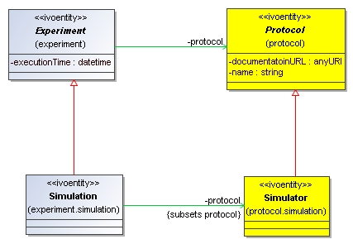
- AssociationEnd: subsets
An often occurring pattern in data modelling is that a base class has a navigable association to another class, which a subclass wishes to refine. An example is the Experiment-protocol-Protocol reference, which is refined by the Simulation-protocol-Simulator reference. It indicates that of all possible Protocol-s, a Simulation only can refer to a Simulator protocol. This is a new feature introduced in UML2 and goes there under the name of subsets and is applied to the refined end of the association. In the diagram it is indicated using a statement ”{subsets …}

References

- Registry resource model…
- SNAP …
- Jonathan McDowell et al, 2006 Data Model for Astronomical Dataset Characterisation v1.0
http://www.ivoa.net/internal/IVOA/IvoaDataModel/CharacterisationWDversion1.0.pdf
- SED model
- Gerard Lemsn & Joerg Colberg 2004 Theory in the Virtual Observatory
- Various books on methodology of data modelling:
  - Fu-Chiu John Cheng, Object-Oriented Design & Analysis, chapter 9, http://www.cse.ttu.edu.tw/~cheng/courses/ooad.htm/F02/ooad09.ppt. After book by David William Brown, Introduction to Object-Oriented Analysis: Objects and UML in Plain English, Wiley, 2001.
  - Bertrand Meyer, 1997, Object-oriented software construction, second edition, Prentice-Hall
  - Terry Halpin, 2001, Information Modelling and Relational Databases, Morgan Kauffman
  - Grady Booch, 1994, Object-oriented Analysis and Design, second edition, Addison-Wesley
- Gerard Lemson, Pat Dowler, Anthony Banday 2004 A unified domain model for astronomy for use in the Virtual Observatory
http://www.ivoa.net/internal/IVOA/IvoaDataModel/DomainModelv0.9.1.doc
- SI specification on http://physics.nist.gov/cuu/Units/introduction.html .
- Martin Fowler 1997, Analysis Patterns, Addisson Wesley
- Ontology of Astronomical Object Types, IVOA Semantics WG 2007
- http://terapix.iap.fr/rubrique.php?id_rubrique=91/
- Characterisation data model …
- Schuecker, P. et al Astronomy and Astrophysics, v.426, p.387-397 (2004)
- http://www.mpa-garching.mpg.de/gadget/ ….
- Concrete data models for simulations … TBD add link to this on the wiki pages
- MNRAS/A&A/ApJ keywords: http://www.journals.uchicago.edu/ApJ/instruct.key.html
http://www.blackwellpublishing.com/pdf/mnraskey.pdf
- Semantic vocabulary (Semantics WG)
http://www.ivoa.net/internal/IVOA/IvoaSemantics/UCDlist-PR20070323.pdf

http://www.ivoa.net/twiki/bin/view/IVOA/IvoaDAL
We use a suite of simulations run by KlausDolag form the MPA and collaborators. Examples of these are available on http://www.g-vo.org/hydrosims/
http://www.ivoa.net/twiki/bin/view/IVOA/TheorySemanticVocabulary
Examples where there is some variation on this are static models (see Becanson model) or models that track times of individual particles (see [TBD proper reference to Peter Teuben’s] models).

